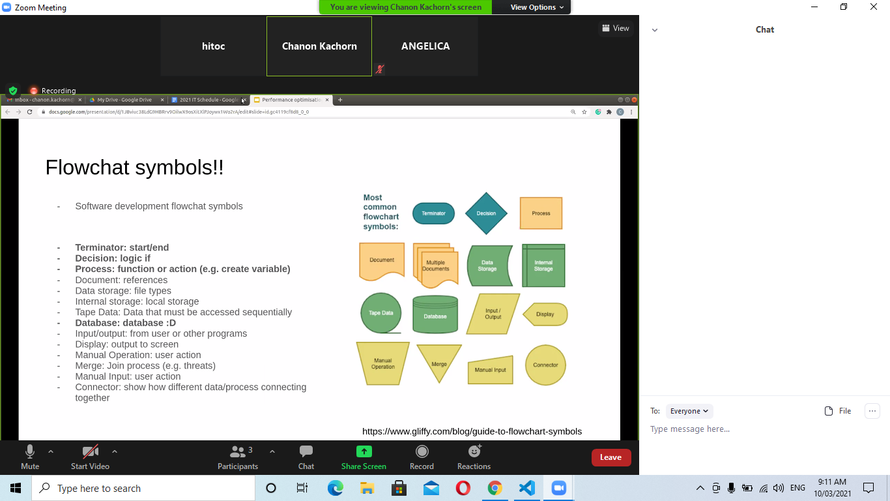

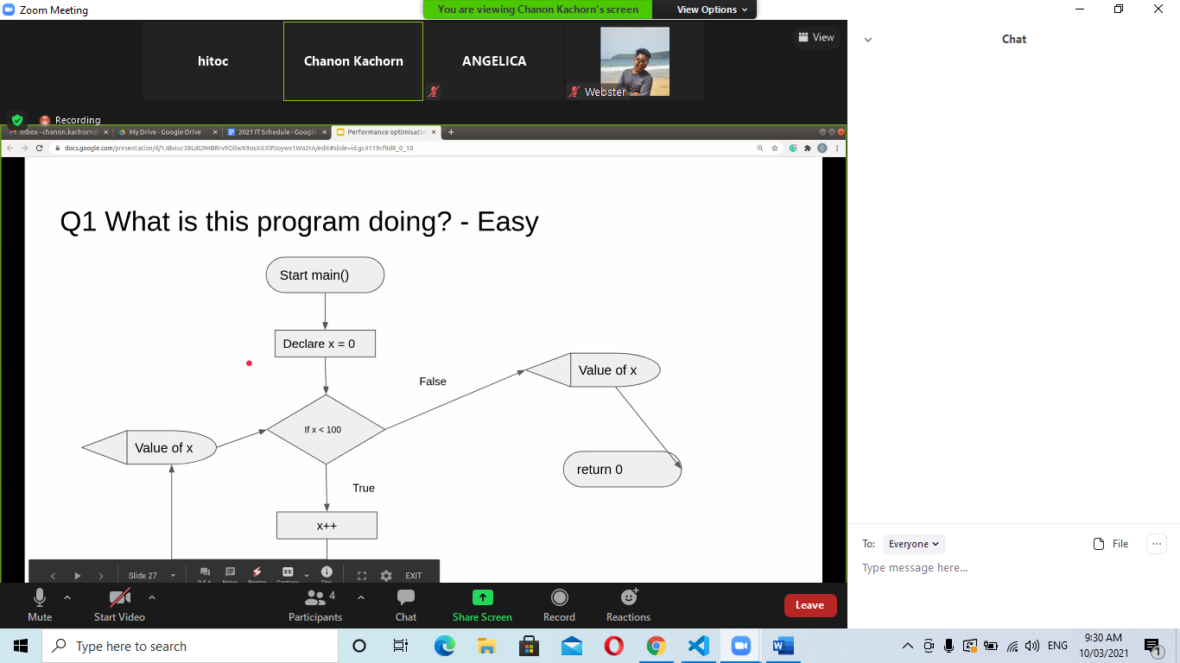

no ; para python

: dsps de 1) if else, 2) loops y 3) funciones declaradas :

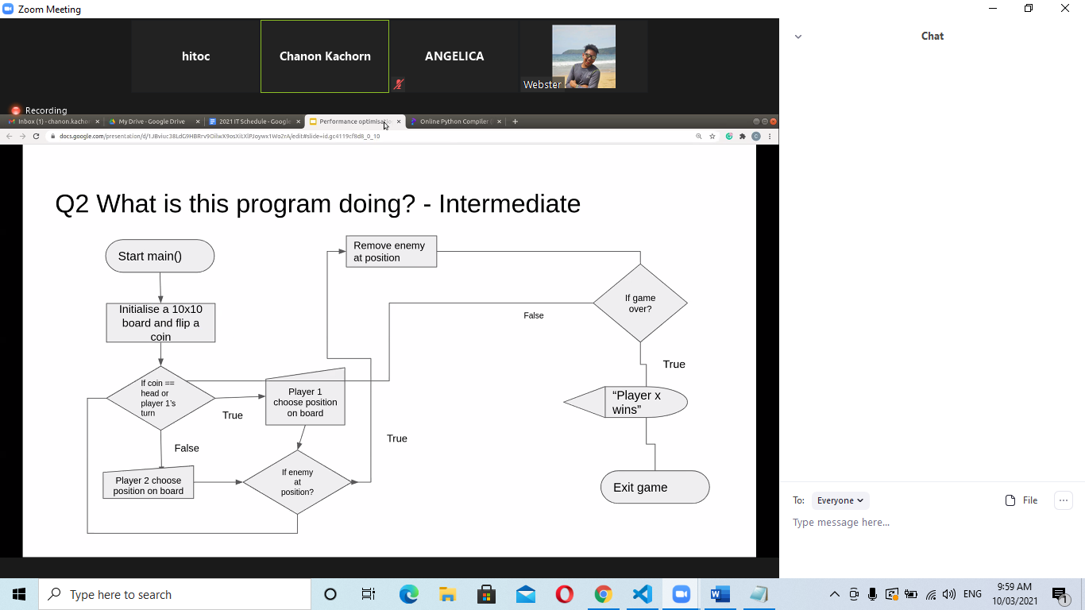

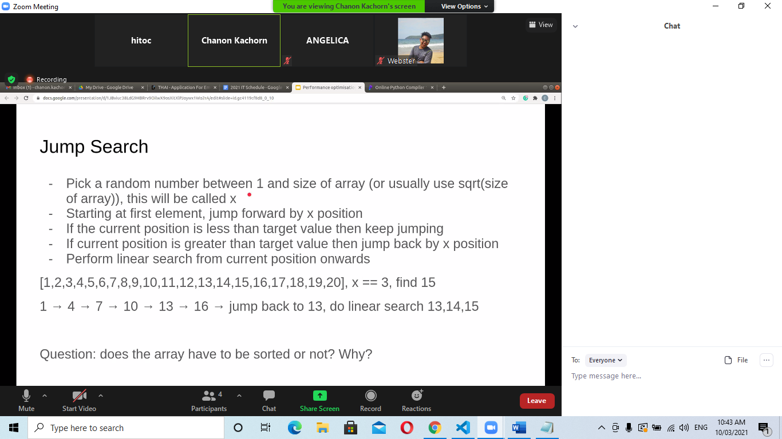

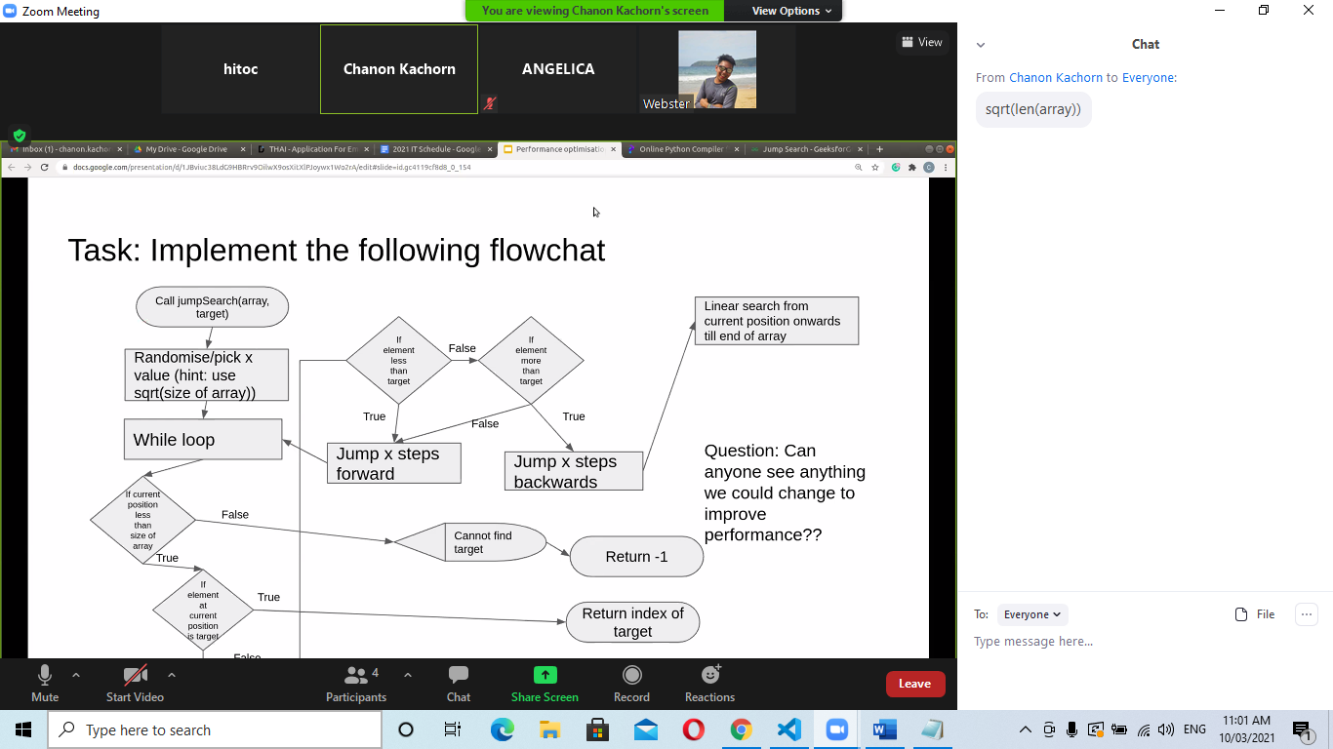

no ; para python

: dsps de 1) if else, 2) loops y 3) funciones declaradas :

board = 10 x 10

x = coin

if coin == head == player's 1

player 1

board

coin

player 1

player 2

enemy

flip

position

remove

win

exit

programs for diagrams powerpoint o word documents

software flowchart

hackathons to practice coding

sqrt is square root

